Supplementary materials: statistical tests’ summary
SF – step forward
SL – step lateral
Cum_freq – cumulative frequencies, number/percentage of cases in the assign bin (e.g. DMCI of 70-80, 80-90 etc. )
One_syn – variance accounted for one synergy
Group – younger(1) and older adults(2)
Independent sample T-Test
Group Statistics
 | Group | N | Mean | Std. Deviation | Std. Error Mean
One_syn_VAF_walk | 1.00 | 13 | 66.89212 | 3.725477 | 1.033261
 | 2.00 | 16 | 69.06277 | 4.020245 | 1.005061
One_syn_VAF_incl | 1.00 | 14 | 66.96588 | 3.092099 | .826398
 | 2.00 | 16 | 68.52744 | 3.627215 | .906804
One_syn_SF | 1.00 | 12 | 82.9071 | 2.65579 | .76666
 | 2.00 | 15 | 85.3540 | 2.89910 | .74854
One_syn_SL | 1.00 | 14 | 82.8448 | 3.80817 | 1.01778
 | 2.00 | 15 | 83.8848 | 3.72274 | .96121

Independent Samples Test
 |  | Levene's Test for Equality of Variances |  | t-test for Equality of Means
 |  | F | Sig. | t | df | Significance |  | Mean Difference | Std. Error Difference | 95% Confidence Interval of the Difference
 |  |  |  |  |  | One-Sided p | Two-Sided p |  |  | Lower | Upper
One_syn_VAF_walk | Equal variances assumed | .319 | .577 | -1.494 | 27 | .073 | .147 | -2.170650 | 1.453247 | -5.152467 | .811167
 | Equal variances not assumed |  |  | -1.506 | 26.484 | .072 | .144 | -2.170650 | 1.441450 | -5.130961 | .789661
One_syn_VAF_incl | Equal variances assumed | .097 | .758 | -1.259 | 28 | .109 | .218 | -1.561552 | 1.240354 | -4.102302 | .979197
 | Equal variances not assumed |  |  | -1.273 | 27.987 | .107 | .214 | -1.561552 | 1.226877 | -4.074747 | .951642
One_syn_SF_GL | Equal variances assumed | .062 | .806 | -2.261 | 25 | .016 | .033 | -2.44690 | 1.08237 | -4.67607 | -.21772
 | Equal variances not assumed |  |  | -2.284 | 24.485 | .016 | .031 | -2.44690 | 1.07149 | -4.65602 | -.23777
One_syn_SL_GL | Equal variances assumed | .003 | .953 | -.743 | 27 | .232 | .464 | -1.03996 | 1.39879 | -3.91004 | 1.83013
 | Equal variances not assumed |  |  | -.743 | 26.762 | .232 | .464 | -1.03996 | 1.39993 | -3.91356 | 1.83365

Independent Samples Effect Sizes
 |  | Standardizer | Point Estimate | 95% Confidence Interval
 |  |  |  | Lower | Upper
One_syn_VAF_walk | Cohen's d | 3.891994 | -.558 | -1.299 | .194
 | Hedges' correction | 4.004444 | -.542 | -1.263 | .188
 | Glass's delta | 4.020245 | -.540 | -1.288 | .225
One_syn_VAF_incl | Cohen's d | 3.389292 | -.461 | -1.184 | .271
 | Hedges' correction | 3.483585 | -.448 | -1.152 | .263
 | Glass's delta | 3.627215 | -.431 | -1.157 | .310
One_syn_SF_GL | Cohen's d | 2.79465 | -.876 | -1.664 | -.071
 | Hedges' correction | 2.88214 | -.849 | -1.614 | -.069
 | Glass's delta | 2.89910 | -.844 | -1.651 | -.011
One_syn_SL_GL | Cohen's d | 3.76412 | -.276 | -1.006 | .458
 | Hedges' correction | 3.87287 | -.269 | -.978 | .445
 | Glass's delta | 3.72274 | -.279 | -1.010 | .461
T-Test
Group Statistics
 | Group | N | Mean | Std. Deviation | Std. Error Mean
DMCI_SF | 1.00 | 12 | 100.0000 | 10.00001 | 2.88676
 | 2.00 | 15 | 90.7866 | 10.91614 | 2.81853
DMCI_SL | 1.00 | 14 | 100.0000 | 10.00001 | 2.67261
 | 2.00 | 15 | 97.2691 | 9.77568 | 2.52407
DMCI_walk | 1.00 | 13 | 100.0000 | 10.00000 | 2.77350
 | 2.00 | 16 | 94.1735 | 10.79122 | 2.69781
DMCI_incl | 1.00 | 14 | 100.0000 | 10.00000 | 2.67261
 | 2.00 | 16 | 94.9499 | 11.73059 | 2.93265

Independent Samples Test
 |  | Levene's Test for Equality of Variances |  | t-test for Equality of Means
 |  | F | Sig. | t | df | Significance |  | Mean Difference | Std. Error Difference | 95% Confidence Interval of the Difference
 |  |  |  |  |  | One-Sided p | Two-Sided p |  |  | Lower | Upper
DMCI_SF | Equal variances assumed | .062 | .806 | 2.261 | 25 | .016 | .033 | 9.21344 | 4.07549 | .81980 | 17.60707
 | Equal variances not assumed |  |  | 2.284 | 24.485 | .016 | .031 | 9.21344 | 4.03454 | .89529 | 17.53159
DMCI_SL | Equal variances assumed | .003 | .953 | .743 | 27 | .232 | .464 | 2.73085 | 3.67313 | -4.80579 | 10.26749
 | Equal variances not assumed |  |  | .743 | 26.762 | .232 | .464 | 2.73085 | 3.67611 | -4.81504 | 10.27674
DMCI_walk | Equal variances assumed | .319 | .577 | 1.494 | 27 | .073 | .147 | 5.82650 | 3.90084 | -2.17735 | 13.83035
 | Equal variances not assumed |  |  | 1.506 | 26.484 | .072 | .144 | 5.82650 | 3.86917 | -2.11962 | 13.77263
DMCI_incl | Equal variances assumed | .097 | .758 | 1.259 | 28 | .109 | .218 | 5.05014 | 4.01136 | -3.16677 | 13.26705
 | Equal variances not assumed |  |  | 1.273 | 27.987 | .107 | .214 | 5.05014 | 3.96778 | -3.07766 | 13.17793

Independent Samples Effect Sizes
 |  | Standardizer | Point Estimate | 95% Confidence Interval
 |  |  |  | Lower | Upper
DMCI_SF | Cohen's d | 10.52287 | .876 | .071 | 1.664
 | Hedges' correction | 10.85229 | .849 | .069 | 1.614
 | Glass's delta | 10.91614 | .844 | .011 | 1.651
DMCI_SL | Cohen's d | 9.88432 | .276 | -.458 | 1.006
 | Hedges' correction | 10.16991 | .269 | -.445 | .978
 | Glass's delta | 9.77568 | .279 | -.461 | 1.010
DMCI_walk | Cohen's d | 10.44697 | .558 | -.194 | 1.299
 | Hedges' correction | 10.74881 | .542 | -.188 | 1.263
 | Glass's delta | 10.79122 | .540 | -.225 | 1.288
DMCI_incl | Cohen's d | 10.96114 | .461 | -.271 | 1.184
 | Hedges' correction | 11.26608 | .448 | -.263 | 1.152
 | Glass's delta | 11.73059 | .431 | -.310 | 1.157
Nonparametric Tests
Hypothesis Test Summary
 | Null Hypothesis | Test | Sig. | Decision
1 | The distribution of Num_syn_walk is the same across categories of Group. | Independent-Samples Mann-Whitney U Test | .056 | Retain the null hypothesis.
2 | The distribution of Num_syn_incl is the same across categories of Group. | Independent-Samples Mann-Whitney U Test | .448 | Retain the null hypothesis.
3 | The distribution of Num_syn_SF_GL is the same across categories of Group. | Independent-Samples Mann-Whitney U Test | .300 | Retain the null hypothesis.
4 | The distribution of Num_syn_SL_GL is the same across categories of Group. | Independent-Samples Mann-Whitney U Test | .201 | Retain the null hypothesis.

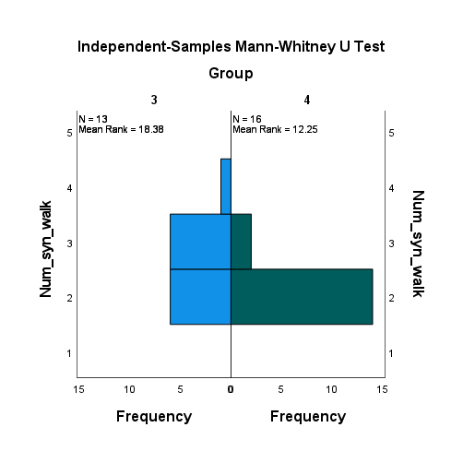
Independent-Samples Mann-Whitney U Test
Num_syn_walk across Group
Independent-Samples Mann-Whitney U Test Summary
Total N | 29
Mann-Whitney U | 60.000
Wilcoxon W | 196.000
Test Statistic | 60.000
Standard Error | 18.409
Standardized Test Statistic | -2.390
Asymptotic Sig.(2-sided test) | .017
Exact Sig.(2-sided test) | .056

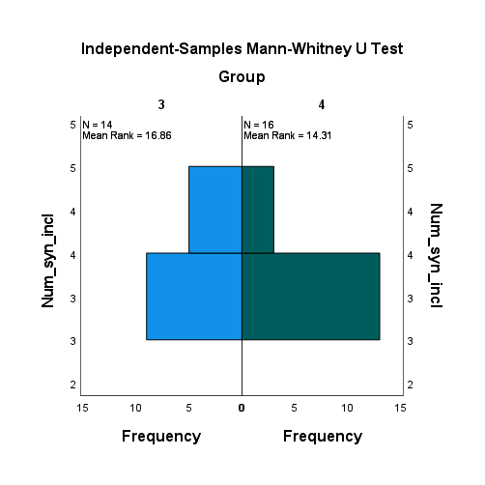
Num_syn_incl across Group

Independent-Samples Mann-Whitney U Test Summary
Total N | 30
Mann-Whitney U | 93.000
Wilcoxon W | 229.000
Test Statistic | 93.000
Standard Error | 18.435
Standardized Test Statistic | -1.031
Asymptotic Sig.(2-sided test) | .303
Exact Sig.(2-sided test) | .448

Num_syn_SF across Group
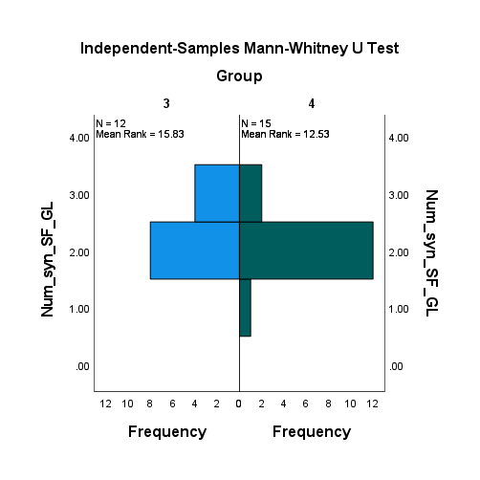
Independent-Samples Mann-Whitney U Test Summary
Total N | 27
Mann-Whitney U | 68.000
Wilcoxon W | 188.000
Test Statistic | 68.000
Standard Error | 15.652
Standardized Test Statistic | -1.406
Asymptotic Sig.(2-sided test) | .160
Exact Sig.(2-sided test) | .300

Num_syn_SL across Group
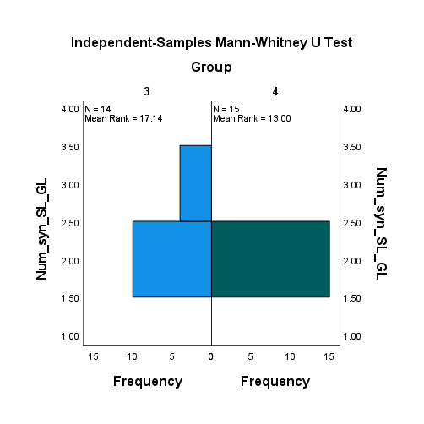
Independent-Samples Mann-Whitney U Test Summary
Total N | 29
Mann-Whitney U | 75.000
Wilcoxon W | 195.000
Test Statistic | 75.000
Standard Error | 13.693
Standardized Test Statistic | -2.191
Asymptotic Sig.(2-sided test) | .028
Exact Sig.(2-sided test) | .201

Frequencies
Statistics
 |  | cum_freq_SF | cum_freq_SL | cum_freq_walk | cum_freq_incl
N | Valid | 27 | 29 | 29 | 29
 | Missing | 3 | 1 | 1 | 1

Frequency Table

cum_freq_SF
 |  | Frequency | Percent | Valid Percent | Cumulative Percent
Valid | 70.00 | 2 | 6.7 | 7.4 | 7.4
 | 80.00 | 7 | 23.3 | 25.9 | 33.3
 | 90.00 | 10 | 33.3 | 37.0 | 70.4
 | 100.00 | 5 | 16.7 | 18.5 | 88.9
 | 110.00 | 3 | 10.0 | 11.1 | 100.0
 | Total | 27 | 90.0 | 100.0
Missing | System | 3 | 10.0
Total |  | 30 | 100.0

cum_freq_SL
 |  | Frequency | Percent | Valid Percent | Cumulative Percent
Valid | 80.00 | 5 | 16.7 | 17.2 | 17.2
 | 90.00 | 15 | 50.0 | 51.7 | 69.0
 | 100.00 | 4 | 13.3 | 13.8 | 82.8
 | 110.00 | 4 | 13.3 | 13.8 | 96.6
 | 120.00 | 1 | 3.3 | 3.4 | 100.0
 | Total | 29 | 96.7 | 100.0
Missing | System | 1 | 3.3
Total |  | 30 | 100.0

cum_freq_walk
 |  | Frequency | Percent | Valid Percent | Cumulative Percent
Valid | 80.00 | 8 | 26.7 | 27.6 | 27.6
 | 90.00 | 12 | 40.0 | 41.4 | 69.0
 | 100.00 | 6 | 20.0 | 20.7 | 89.7
 | 110.00 | 2 | 6.7 | 6.9 | 96.6
 | 120.00 | 1 | 3.3 | 3.4 | 100.0
 | Total | 29 | 96.7 | 100.0
Missing | System | 1 | 3.3
Total |  | 30 | 100.0

cum_freq_incl
 |  | Frequency | Percent | Valid Percent | Cumulative Percent
Valid | 70.00 | 1 | 3.3 | 3.4 | 3.4
 | 80.00 | 7 | 23.3 | 24.1 | 27.6
 | 90.00 | 7 | 23.3 | 24.1 | 51.7
 | 100.00 | 10 | 33.3 | 34.5 | 86.2
 | 110.00 | 4 | 13.3 | 13.8 | 100.0
 | Total | 29 | 96.7 | 100.0
Missing | System | 1 | 3.3
Total |  | 30 | 100.0

